How to encode club grades in SIS - Grading.
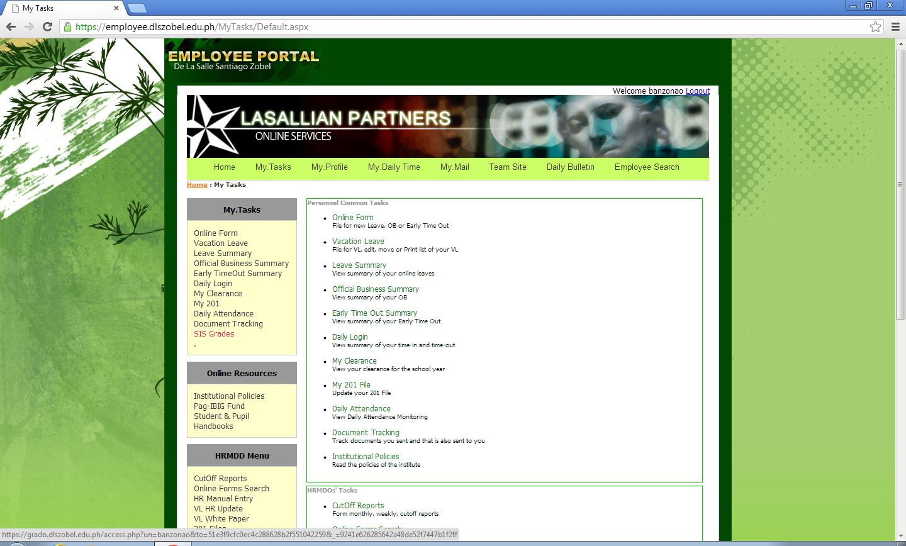
- Log into the EMPLOYEE PORTAL, click My Tasks in the menu links, then under My Tasks pane on the left click SIS Grades.

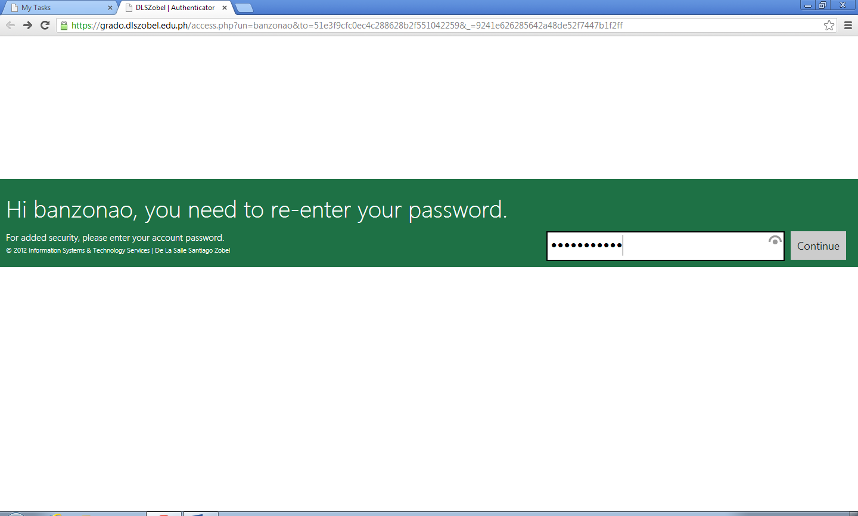
- Verify your username and re-enter your password.

- Click Grading in the menu links, then click Encode Score button beside the SUBJECT you wish to encode.

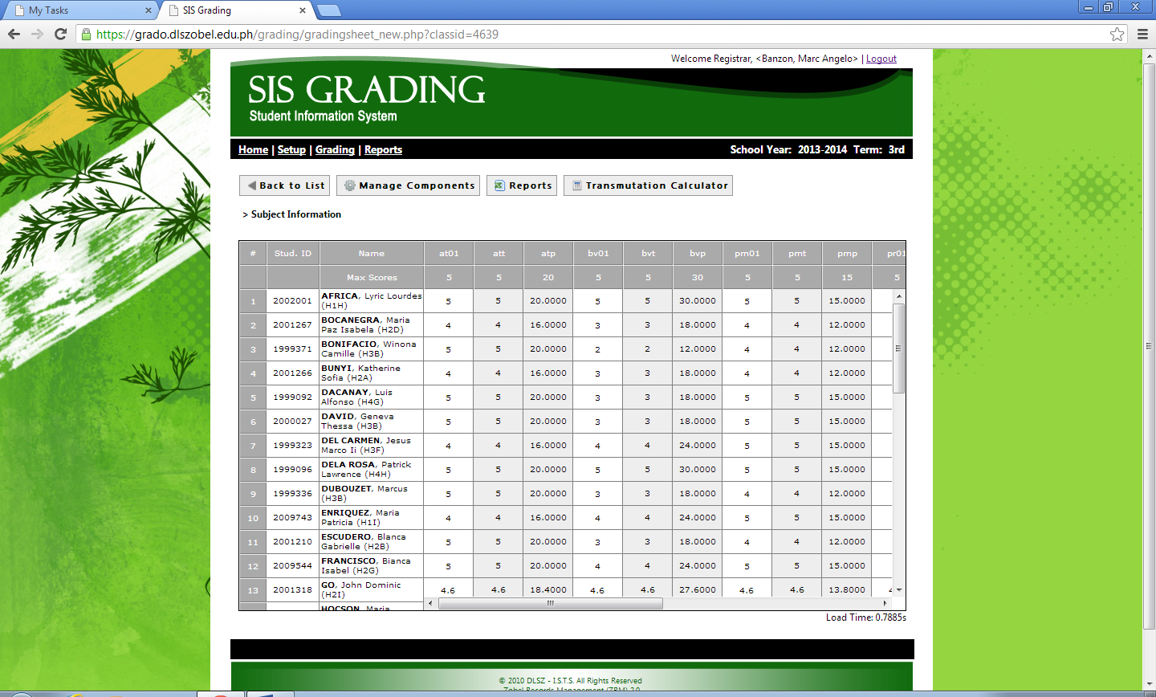
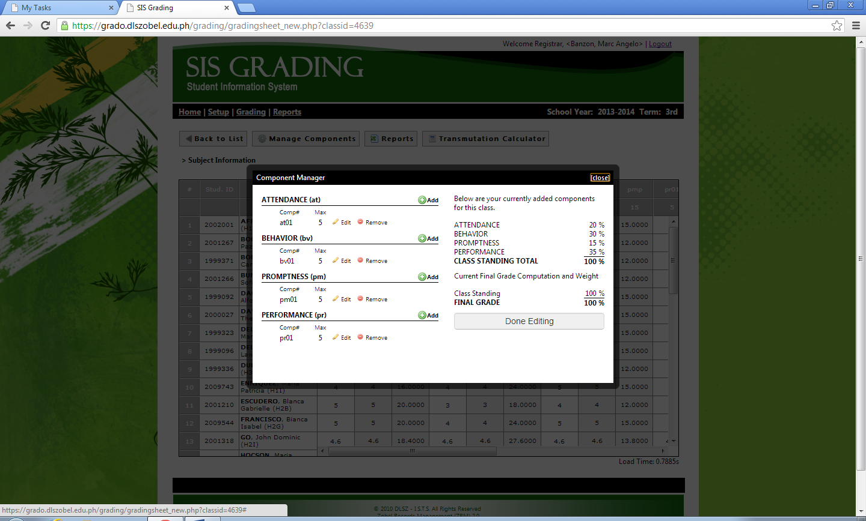
- Click Manage Components, then use the pop up Component Manager window to Add, Edit or Remove components.

